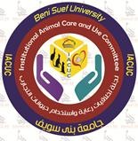

Dear Dr
Institutional Animal Care and Use Committee Beni-Sue Univesity (BSU-IACUC)
Approval to use animals

This letter is to inform you that the following animal protocol was approved by BSU-IACUC reviewers
Approval number ……… Title……………………………..
.

est wishes

Prof. Dr. Fatma Hassn Mohammed
Chair BSU-IACUC

Contact
http://www.bsu.edu.eg/IACUC.aspx

Tel: 01066186657- 01111399114- 01001084893

mail: iacuc@bsu.edu.eg

